# Physics IA Proposal

## Topic

### Foreword

As I realized that my last proposed topic would not work after doing an actual experiment to try it out, I entered eternal depression anxiety, and decided to move on with life. I have then tried a few more topics such as tesla coil’s wireless power transfer v.s. distance, frequency v.s. tension, temperature v.s. elasticity, and a few more that was so catastrophic that I would not want to list. At the end, the conclusion was that none of these would work well with my taste, so I entered eternal depression and abandoned all of them. As I soullessly wondered around, I saw my piano, so I started to play my favorite anime song on it. As I was playing, I realized that the pressure that I put on the keys does not have a quite linear relationship with the sound that it produces. This caught my interest, as this none-linear relationship may be a good choice for my physics IA. So I rushed to my bed and slept to prepare to derive the formula tomorrow. The next day, I derived a formula with such a weird curve, that I haven’t even seen it in math before, so I thought that it would be a decent choice at least difficulty wise, so I decided to investigate the loudness of a string v.s. the force striking it.

### General

The Experiment that I am planning to carry out is supposed to demonstrate the relationship between the amplitude of a sound wave v.s. the force used to strike the string that produces that sound wave

### Topic related to

Kinematics

Wave

Conservation of energy

### Hypothesis

If the force striking the string is increased, the amplitude of the sound wave will also increase none-linearly (I do not what this relationship is called, does look like a inverted quadratic tough, need investigation to find out), because the force stroked onto the string would be proportional to the length increase of the string according to hook’s law, and using Pythagorean theorem, a inverted quadratic relationship can be found, and the force used to move the string is negligible due to the light weight of the string.

## Variables

|  |  |  |  |
| --- | --- | --- | --- |
| Variable type | Variable | Method to measure | Method to control |
| Independent | Striking force | Force gage | Measure out the distance which a rubber band expand to exert one newton of force, and tie n rubber bands on to the striking rod to achieve n newtons of force. |
| Dependent | Amplitude of wave | Microphone input to computer, which returns amplitude of audio file with program | Do not control this variable |
| External independent | Length of string | Ruler | Measure distance between two knobs, and wrap string in-between |
| External independent | Spring constant of string | Measure with force gage with distant expanded | Do not control |
| External independent | Tension already in string | Length of extension with spring constant | Turn knob to tighten string. Diameter of knob will be 1cm. |
| External independent | Background noise | Microphone input to computer, which returns amplitude of audio file with program | Yell at other people in class room to shut up and be quiet and be a good kid |
| External independent | temperature | Glass thermometer measure room temperature | Do not open window or door to maintain same room temperature. |
| External independent | vibration of same natural frequency | Microphone and computer | Make sure no one record my experiment and replay it while I am doing it |

## Design

### Diagram

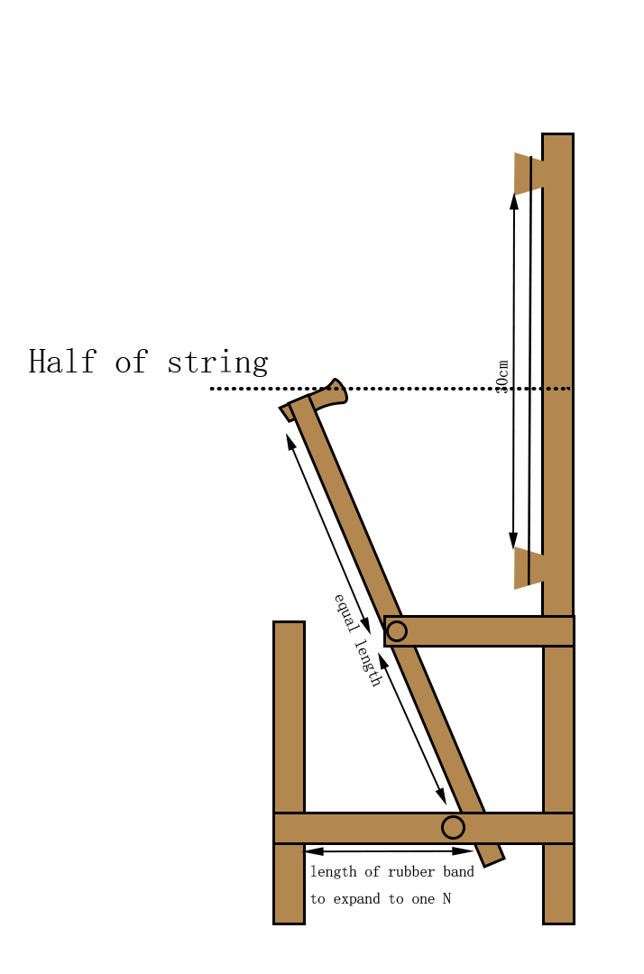

### Material

* wood
* string (guitar)
* rubber band
* very few nails

### Description

Rubber band will be put on the left foot, and tied to the end of the lever, each exerting one N to the system. The wooden pick can then be removed to release to lever which strikes the string at that applied force. Note that the distance from the other end of the lever to the string should be less then the length which a rubber band expands into with one N of force. A microphone will be placed on the long beam, and records the sound wave produced by the string. The data will then be interpreted by computer software to return the amplitude of the wave. The design will work, because I got inspiration from how a piano function.

## Formula

### RelationshipC:\Users\chaih\Downloads\desmos-graph.png

x-axis is force in newtons

y-axis is amplitude in m

medium is a guitar string (22929N/m)

length is 30 cm

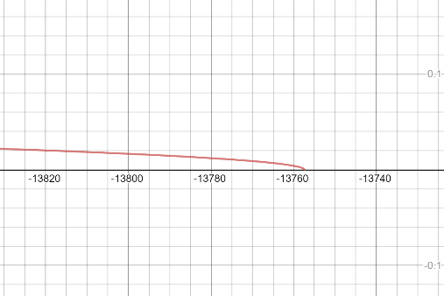 There is also this on the other side (very far left)

### Deriving

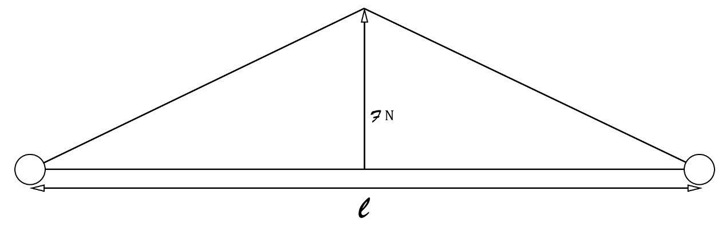

In this diagram, the force F is mostly used to stretch the string, the amount of force used to display the string can be neglected since string is very light

The extension in the length of the string can be calculated using hook’s law:

Rearranging, we get

Where k is the spring constant

To calculate the distance displaced, we can use Pythagorean theorem

The hypotenuse would be half of the expanded string length:

Where is the force striking the string and is the length of string after tied onto the system

However, the string would already have some tension in it

Where is original length of string with no tension and is the tension force on the string

and the lever is supposed to strike the middle of the string

## Safety

|  |  |  |
| --- | --- | --- |
| Item | Problem | Solution |
| Rubber band | May fly off to other people’s face and break | Use new ones with better quality |
| Nails | Structure bad cause nail to fall out | Be careful when building the structure, and use as least nails as possible |
|  | Nails holding string in place may fail and explode out | Use multiple nails with good quality on that part of the build, and wear googles |
|  | Nail fall on ground and people step on it | Pay attention during experiment and do it on table, so if anything, bad happen, able to notice |
| Wood | Wood chips may hurt hand when handling | Wear glove |
|  | People may fool around and horse play with experiment tools | Fallow proper lab safety and tell people to fallow their manners |